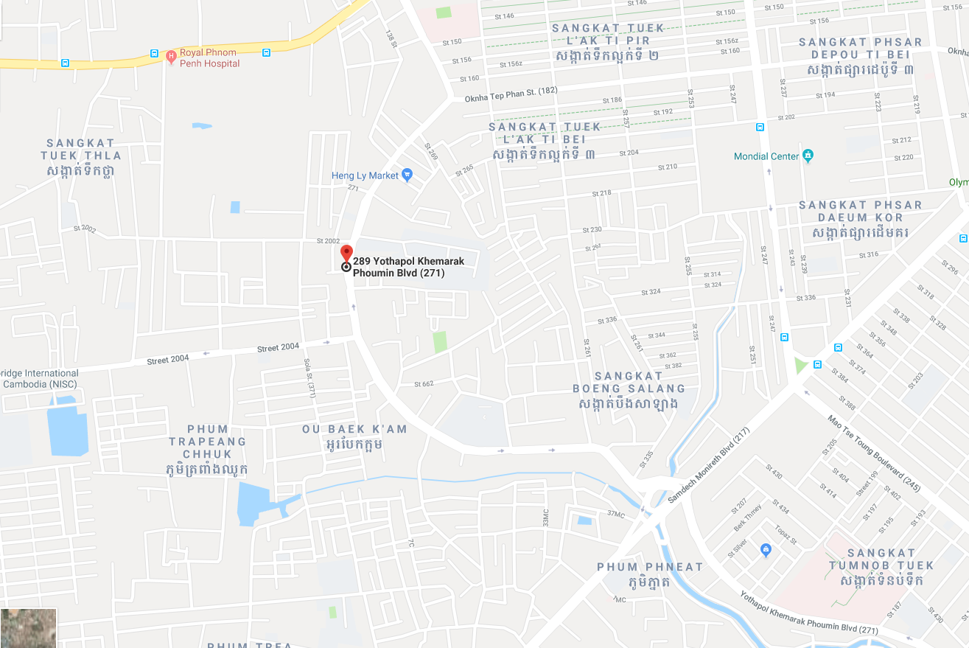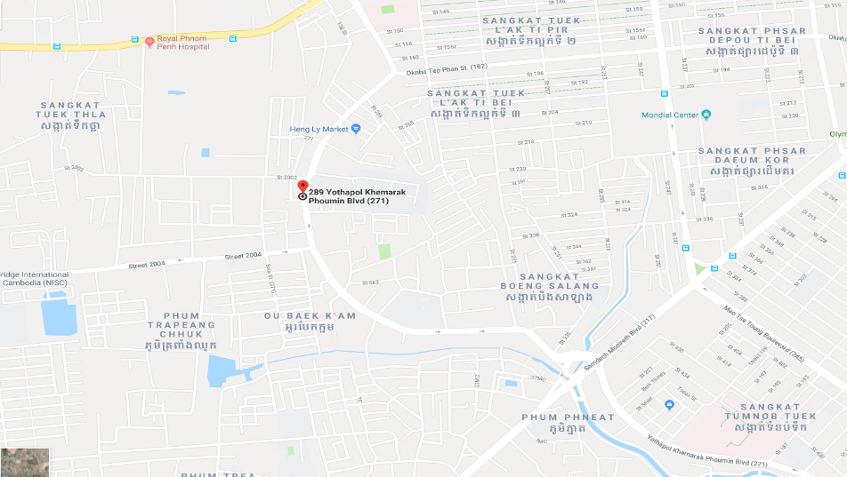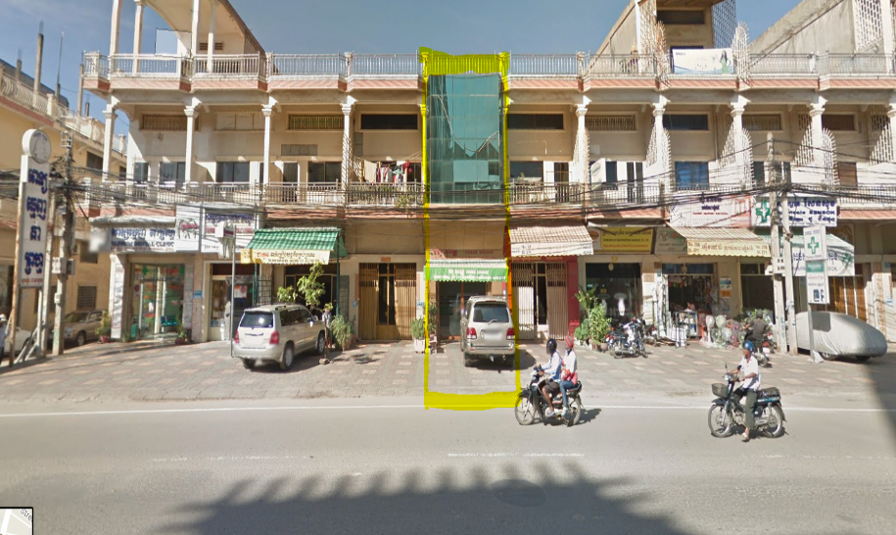

**Melbourne Office**

31 Snowgum Court Keysborough, vic 3173

Tel: (+61)

012 507171

070 507171

**Adelaide Office**

20 Vanessa Dr Burton SA 5110  
Tel: (+61)

012 507171

070 507171

**Cambodia Office**

35beo, Street 271, Toek Thla Quarter,   
Sen Sok District, Phnom Penh

Tel: (+855)

012 507171

070 507171